In the result of the open bidding FGC UES has taken a decision to enter into an agreement with Izolyator factory for supply of high-voltage bushings with RIP-insulation* for a total sum of 3 890 000 USD.
This contract provides supplies to the following affiliated branches of FGC UES:
Main Power Grids of the East
Main Power Grids of the Volga
Main Power Grids of the Siberia
Main Power Grids of the Western Siberia
Main Power Grids of the Ural
Main Power Grids of the South
Main Power Grids of the Center
Main Power Grids of the North-West
JSC Elektrosetservice UNEG (Unified National (All-Russian) Electric Grid)

*At present Izolyator Plant produces high-voltage bushings with RIP-insulation, type “Oil-Air” and “Air-Air” for alternative and direct current, rated up to 1200 kV / 5400 A level.

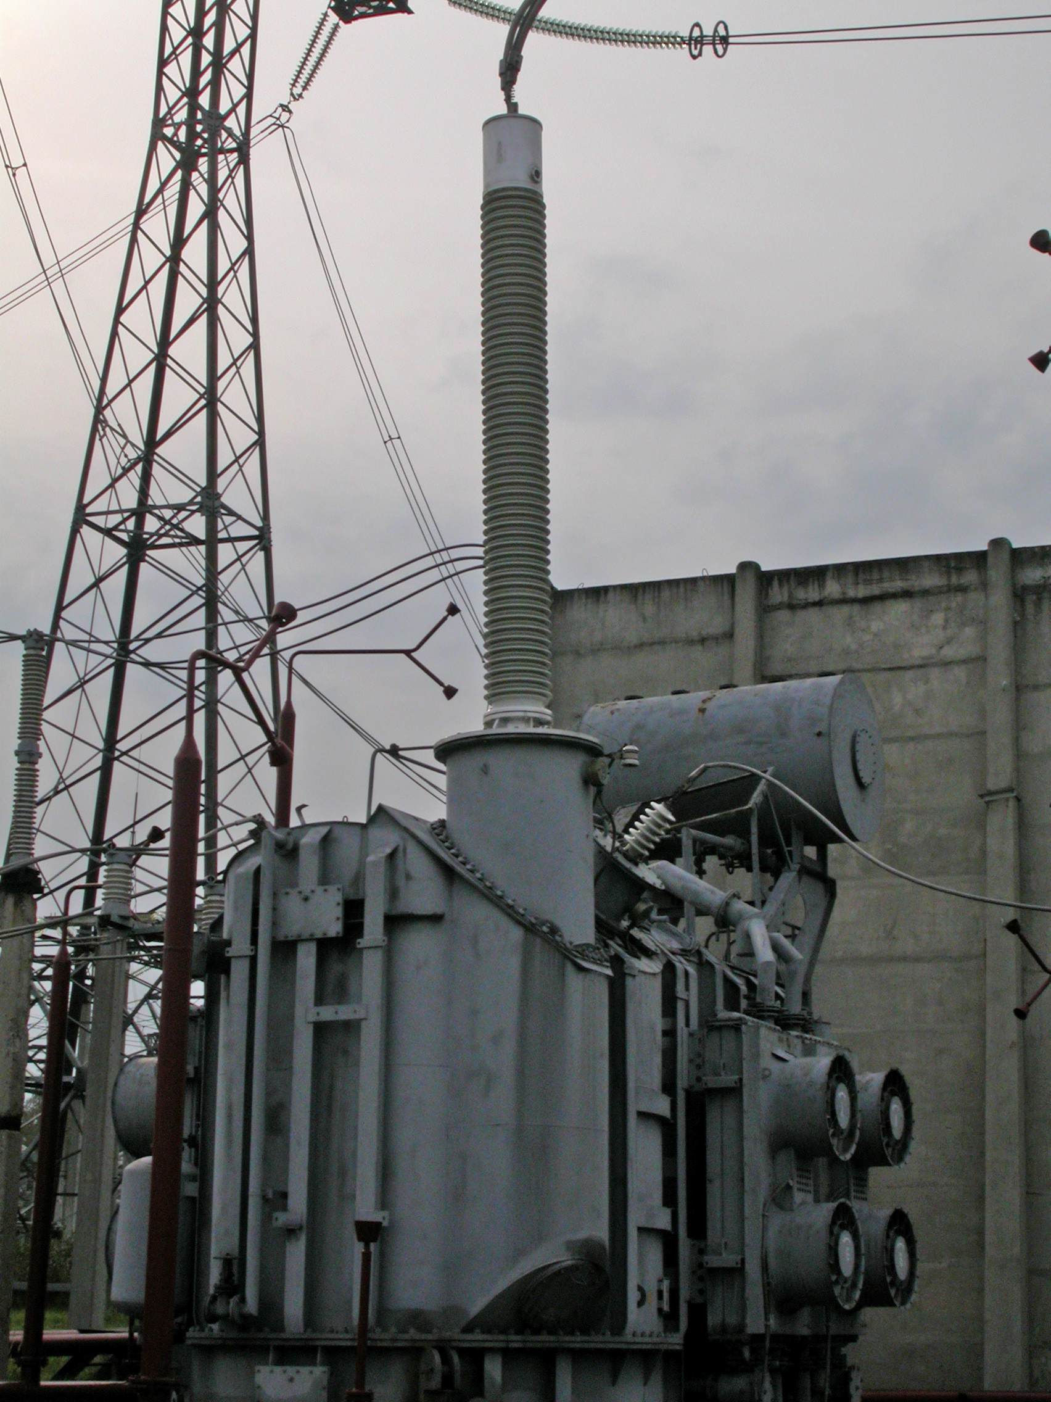
550 kV bushing with RIP-insulation at 167 MVA transformer.
Main Power Grids of the Center

